# Infrared Remote Control Experiment

## Introduce to Infrared receiver tube

## Infrared receiver tube, it is a kind of sensor that can identify infrared.Integrated reception and modulation of 38kHZ infrared sensor.In order to avoid the interference of other infrared signals in the wireless transmission process, the infrared remote control usually modulates the signal on a specific carrier frequency, and then it is sent out by the infrared emitting diode.When the infrared receiver needs to filter out other clutter, it receives a specific frequency signal and returns it to binary pulse code, that is, demodulation.

## Working Principle

## The built-in receiving tube converts the optical signal sent by the infrared transmitter tube into weak current signal, which is amplified by internal IC, and then restored to the original code sent by the infrared remote control through automatic gain control, bandpass filtering, demodulation, waveform shaping, and the decoding circuit input to the electrical appliance through the output pin of the receiving head

## Experiment Purpose

The buttons of the remote control are coded through Ardunio

Arduino UNO main control board communicates with infrared receiver. If the "<" button of the remote control is pressed, the fan turn left; if the ">" button is pressed, the fan turn right “ok” button is pressed,

fan start run, when “ok” pressed again, fan stop.

## Introduction of NEC

### Characteristics

8 address bits, 8 command bits

Address bits and command bits are transmitted twice in order to ensure reliability

Pulse-position modulation

Carrier frequency 38kHz

Every bit lasts 1.125ms or 2.25ms

### The definitions of logic 0 and 1 are as below



### Transmitted pulse which the pressed button released immediately



The picture above shows a typical pulse sequence of the NEC protocol. Notice: The protocol of LSB (least significant) is firstly transmitted. In the above, pulse transmission address is 0x16 and the command is 0x59. A message starts from a 9ms high level, then followed by a 4.5ms low level, and by the address code and command code. The address and command are transmitted twice. All bits flip in the second transmission, this can be used in the confirmation of the received message. The total transmission time is constant, because every bit repeats the flip length. If you are not interested, you can ignore this reliable inversion and expand the address and command every 16 bit as well !

**Transmission pulse for a period of time when the button is pressed**

Even if you press the button on the remote control again, the command is only sent once. When the button is pressed, the first 110ms pulse is the same as above, and then the same code is sent every 110ms. The next repetition code consists of 9ms high-level pulse, 2.25ms low-level pulse and 560μs high-level pulse.

Note: When the integrated head receives pulses, the head needs to decode, amplify and shape the signal. So we should notice that the output is high when the infrared signal is not present, otherwise the output is low, so the output signal level is reversed in the transmitter. We can see the pulse of the receiver through the oscilloscope and understand the program through the waveform.

## 组件清单

* RaspberryPi mainboard
* Breadboard
* USB data cable
* Infrared remote control * 1
* Integrated infrared receiver module * 1
* DC motor*1
* Fan*1
* Servo*1
* Motor drive board*1
* Motor bracket kit*1
* Battery*1
* Several jumpers

## 接线

|  |  |
| --- | --- |
| RaspberryPi 主板 | Steering gear module |
| 5V | VCC |
| GND | GNG |
| IO28(wiringPi)/20(BCM) | S |
| RaspberryPi 主板 | Infrared remote control |
| 5V | + |
| GND | - |
| IO24(wiringPi)/19(BCM) |  |
| RaspberryPi主板 | Motor drive board |
| 5V | 5V(+) |
| GND | GND(-) |
| IO22(wiringPi)/6(BCM) | IN4 |
| Motor drive board | DC motor |
| VCC | + |
| OUT4 | - |

**实物接线**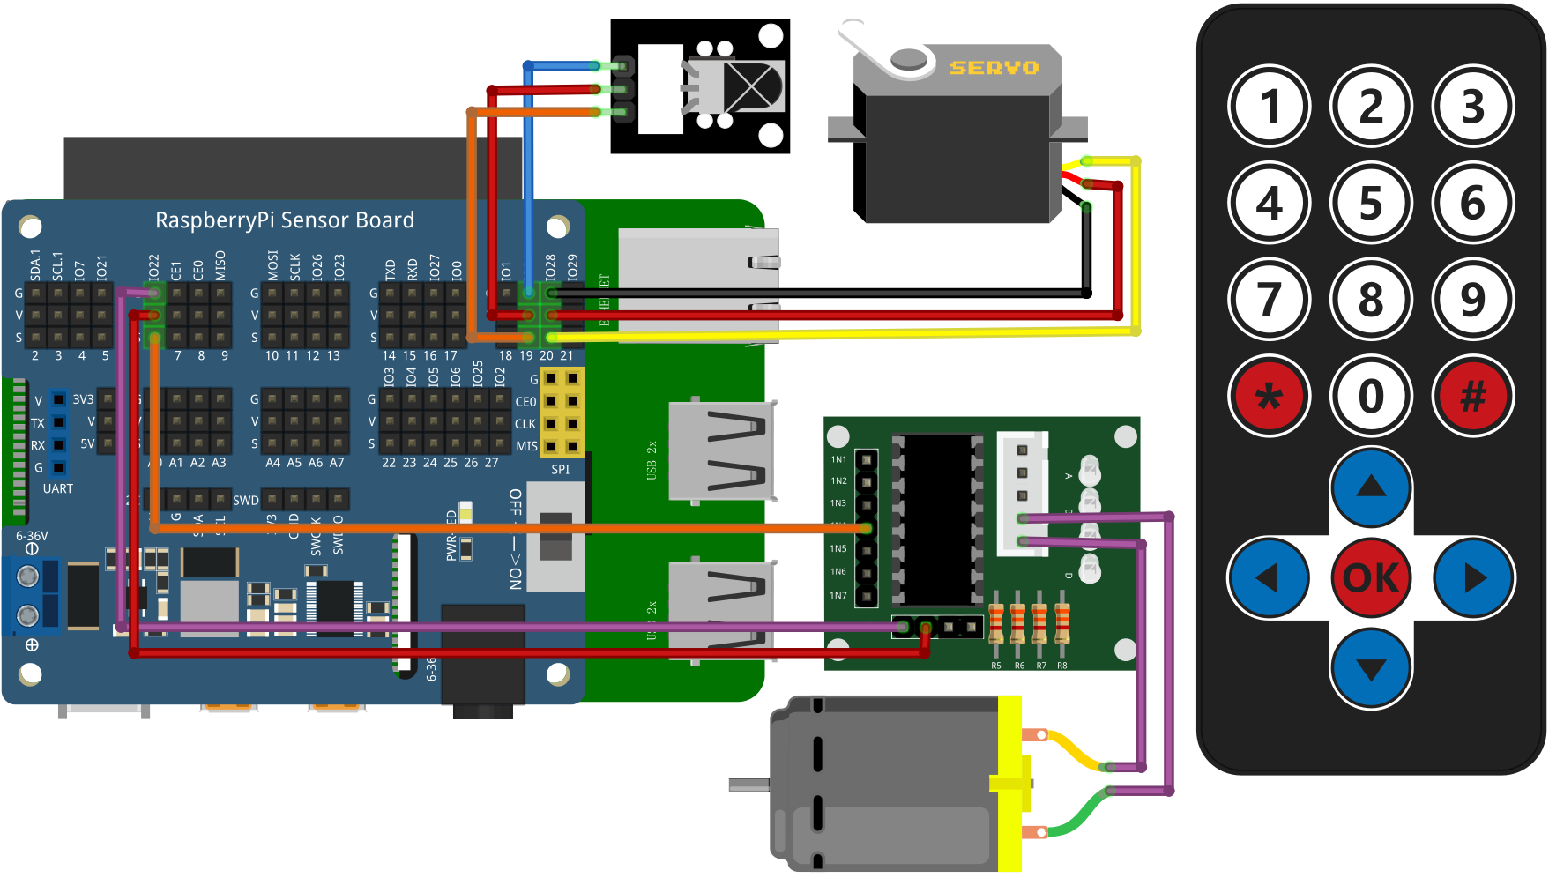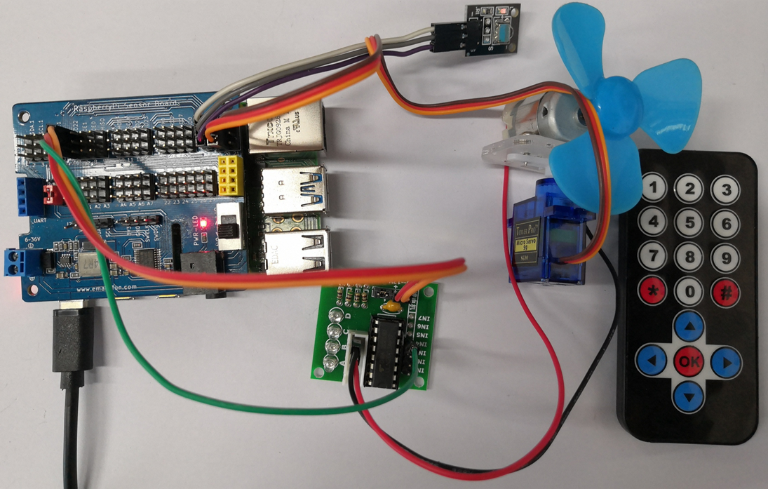

## C++ program

|  |
| --- |
| #include "IR_REC.h"  int main**()**  **{**  int flag**;**  **if(**wiringPiSetup**()** **==** **-**1**){**  printf**(**"setup wiringPi failed !"**);**  **return** 1**;**  **}**  **while(**1**){**  key **=** Change_Map**(**GetKey**());**  **if** **(**key **!=** ERROR**)** **{**  printf**(**"Change_Map %s \n"**,**keymap**[**key**].**keyname**.**c_str**());**  **switch** **(**key**)** **{**// Determine which button is pressed and execute the corresponding program  **case** IR_KEYCODE_OK**:**  printf**(**"IR_KEYCODE_OK key\n"**);**  flag **=** **!**flag**;**  digitalWrite**(**MotorPin**,** flag**);**// Control the motor  **break;**  **case** IR_KEYCODE_LEFT**:**  pwm_fun**(**0**);**  delay**(**500**);**// Control the steering gear to turn to 0 degree  printf**(**"IR_KEYCODE_OK left\n"**);**  **break;**  **case** IR_KEYCODE_RIGHT**:**  pwm_fun**(**180**);**  delay**(**500**);**//Control the steering gear to turn 180 degrees  printf**(**"IR_KEYCODE_OK right\n"**);**  **break;**  **}**  **}**  **}**  **}** |

## Python program

|  |
| --- |
| #!/usr/bin/python  # -*- coding:utf-8 -*-  **import** RPi**.**GPIO **as** GPIO  **import** time  ERROR **=** 0xFE  PIN **=** 19  flag **=** 0  motor **=** 6  servopin **=** 20  #Define infrared receiver pin  keymap **=** **{**  0x45**:**"1"**,**  0x46**:**"2"**,**  0x47**:**"3"**,**  0x44**:**"4"**,**  0x40**:**"5"**,**  0x43**:**"6"**,**  0x07**:**"7"**,**  0x15**:**"8"**,**  0x09**:**"9"**,**  0x19**:**"0"**,**  0x16**:**"*"**,**  0x0D**:**"#"**,**  0x18**:**"up"**,**  0x52**:**"down"**,**  0x1C**:**"ok"**,**  0x08**:**"left"**,**  0x5A**:**"right"**,**  0xfe**:**0xfe  **}**    GPIO**.**setmode**(**GPIO**.**BCM**)**  GPIO**.**setwarnings**(False)**  GPIO**.**setup**(**PIN**,** GPIO**.**IN**,** GPIO**.**PUD_UP**)** # Set the infrared receiving pin to pull-up mode  GPIO**.**setup**(**motor**,**GPIO**.**OUT**)**  GPIO**.**setup**(**servopin**,**GPIO**.**OUT**)**    **def** getKey**():**  byte **=** **[**0**,** 0**,** 0**,** 0**]**  **if** IRStart**()** **==** **False:** # Judge the infrared guidance pulse  time**.**sleep**(**0.11**)** # One message frame lasts 108 ms.  **return** ERROR  **else:**  **for** i **in** range**(**0**,** 4**):**  byte**[**i**]** **=** getByte**()** # Receive 32-bit infrared data (address, address inversion, data, data inversion)  **if** byte**[**0**]** **+** byte**[**1**]** **==** 0xff **and** byte**[**2**]** **+** byte**[**3**]** **==** 0xff**:** # Verify that the received data is correct  #print("right")  **return** byte**[**2**]**  **else:**  #print("error")  **return** ERROR  #return byte[2]  **def** IRStart**():** # Judge the infrared guidance pulse  timeFallingEdge **=** **[**0**,** 0**]**  timeRisingEdge **=** 0  timeSpan **=** **[**0**,** 0**]**  # Read pulse time by pulse rising and falling edge  GPIO**.**wait_for_edge**(**PIN**,** GPIO**.**FALLING**)**  timeFallingEdge**[**0**]** **=** time**.**time**()**  GPIO**.**wait_for_edge**(**PIN**,** GPIO**.**RISING**)**  timeRisingEdge **=** time**.**time**()**  GPIO**.**wait_for_edge**(**PIN**,** GPIO**.**FALLING**)**  timeFallingEdge**[**1**]** **=** time**.**time**()**    timeSpan**[**0**]** **=** timeRisingEdge **-** timeFallingEdge**[**0**]** # First pulse time  timeSpan**[**1**]** **=** timeFallingEdge**[**1**]** **-** timeRisingEdge # Second pulse time  #print(timeSpan[0],timeSpan[1])  **if** timeSpan**[**0**]** **>** 0.0085 **and** timeSpan**[**0**]** **<** 0.0095 **and** timeSpan**[**1**]** **>** 0.004 **and** timeSpan**[**1**]** **<** 0.005**:**  #print("1")  **return** **True**  **else:**  #print("0")  **return** **False**  **def** getByte**():** # Receive 32-bit infrared data (address, address inversion, data, data inversion)  byte **=** 0  timeRisingEdge **=** 0  timeFallingEdge **=** 0  timeSpan **=** 0  **for** i **in** range**(**0**,** 8**):**  # Read pulse time by pulse rising and falling edge  GPIO**.**wait_for_edge**(**PIN**,** GPIO**.**RISING**)**  timeRisingEdge **=** time**.**time**()**  GPIO**.**wait_for_edge**(**PIN**,** GPIO**.**FALLING**)**  timeFallingEdge **=** time**.**time**()**    timeSpan **=** timeFallingEdge **-** timeRisingEdge # Read pulse time  **if** timeSpan **>** 0.0016 **and** timeSpan **<** 0.0018**:** # Determine whether the pulse is representative 1  byte **|=** 1 **<<** i  **return** byte    **def** change_map**(**key_val**):**  **for** index **in** keymap**.**keys**():**  **if** index **==** key_val **:**  **return** keymap**[**index**]**    **def** pwm_change**(**temp**):**  GPIO**.**output**(**servopin **,True)**  time**.**sleep**(**0.0005**+**float**(**temp**)\***0.0005**/**45**)**  GPIO**.**output**(**servopin **,** **False)**  time**.**sleep**(**0.02**-(**0.0005**+**float**(**temp**)\***0.0005**/**45**))**    **print(**'IRM Test Start ...'**)**  **try:**  **while** **True:**  # Read infrared pulse  key **=** change_map**(**getKey**())**  **if(**key **!=** ERROR**):**  **print(**"Get the key:" **+** key**)**  **if(**key **==** "ok"**):**  **print(**"IR_KEYCODE_OK key"**)**  flag **=** 1 **-** flag  GPIO**.**output**(**motor**,**flag**)**    **if(**key **==** "left"**):**  **print(**"IR_KEYCODE_left key"**)**  pwm_change**(**0**)**  time**.**sleep**(**0.5**)**    **if(**key **==** "right"**):**  **print(**"IR_KEYCODE_right key"**)**  pwm_change**(**180**)**  time**.**sleep**(**0.5**)**    **except** KeyboardInterrupt**:**  GPIO**.**cleanup**()** |

**Java program**

|  |
| --- |
| **import** com**.**pi4j**.**wiringpi**.**Gpio**;**  **import** java**.**util**.**HashMap**;**  **import** java**.**util**.**Iterator**;**  **import** java**.**util**.**Map**;**  **import** java**.**util**.**Map**.**Entry**;**  **import** java**.**util**.**Set**;**  public class IR_NEC **{**  static int PIN **=** 24**,** motor **=** 22**,** PWMPIN **=** 28**;**  static int ERROR **=** 0xfe**,** key**,** flag **=** 0**;**  static long timeRisingEdge**,** timeFallingEdge**,** timeRising**,** timeFalling_0**,** timeFalling_1**;**  static long timeSpan_val **=** 0**;**  static long**[]** time_span **=** **new** long**[**2**];**  static Map**<**Integer**,** String**>** map **=** **new** HashMap**<>();**  static **{**  **if** **(**Gpio**.**wiringPiSetup**()** **==** **-**1**)** **{**  System**.**out**.**println**(**" ==>> GPIO SETUP FAILED"**);**  **}**  Gpio**.**pinMode**(**motor**,** Gpio**.**OUTPUT**);**  Gpio**.**pinMode**(**PWMPIN**,** Gpio**.**OUTPUT**);**    // store data in map collection  map**.**put**(**0x45**,** "1" **);**  map**.**put**(**0x46**,** "2" **);**  map**.**put**(**0x47**,** "3" **);**  map**.**put**(**0x44**,** "4" **);**  map**.**put**(**0x40**,** "5" **);**  map**.**put**(**0x43**,** "6" **);**  map**.**put**(**0x07**,** "7" **);**  map**.**put**(**0x15**,** "8" **);**  map**.**put**(**0x09**,** "9" **);**  map**.**put**(**0x19**,** "0" **);**  map**.**put**(**0x16**,** "*" **);**  map**.**put**(**0x0D**,** "#" **);**  map**.**put**(**0x18**,** "up"**);**  map**.**put**(**0x52**,** "down"**);**  map**.**put**(**0x1C**,** "ok"**);**  map**.**put**(**0x08**,** "left"**);**  map**.**put**(**0x5A**,** "right"**);**  map**.**put**(**0xfe**,** "error"**);**  Gpio**.**pinMode**(**PIN**,** Gpio**.**INPUT**);**  **}**    public static boolean IRStart**()** **{**  **while(!(**Gpio**.**digitalRead**(**PIN**)** **==** 0**));**  timeFalling_0 **=** gettimeofday**();**  **while(!(**Gpio**.**digitalRead**(**PIN**)** **==** 1**));**  timeRising **=** gettimeofday**();**  **while(!(**Gpio**.**digitalRead**(**PIN**)** **==** 0**));**  timeFalling_1 **=** gettimeofday**();**  time_span**[**0**]** **=** timeRising **-** timeFalling_0**;**  time_span**[**1**]** **=** timeFalling_1 **-** timeRising**;**  // System.out.println("start_time " + time_span[0] + "," +time_span[1]);  **if** **(**time_span**[**0**]** **>** 8500 **&&** time_span**[**0**]** **<** 9500 **&&** time_span**[**1**]** **>=** 4000 **&&** time_span**[**1**]** **<=** 5000**)**  **{**  // System.out.println("start singe*************");  **return** **true;**  **}**  **else** **{**  **return** **false;**  **}**  **}**    public static long gettimeofday**()** **{**  // return System.currentTimeMillis() ;// +System.nanoTime() / 1000;  **return** System**.**nanoTime**()** **/** 1000**;**  **}**  public static int GetByte**()** **{**  int byte_val **=** 0**;**  **for** **(**int i **=** 0**;** i **<** 8**;** i**++)** **{**  **while(!(**Gpio**.**digitalRead**(**PIN**)** **==** 1**));**  timeRisingEdge **=** gettimeofday**();**  **while(!(**Gpio**.**digitalRead**(**PIN**)** **==** 0**));**  timeFallingEdge **=** gettimeofday**();**  timeSpan_val **=** timeFallingEdge **-** timeRisingEdge**;**  // System.out.print("start byte ");  // System.out.println(timeSpan_val);  **if** **(**timeSpan_val **>** 1500 **&&** timeSpan_val **<** 1800**)**  byte_val **|=** 1 **<<** i**;**  **}**  // System.out.printf("byte_val: %x \n", byte_val);  **return** byte_val**;**  **}**    public static int GetKey**()** **{**  int**[]** byte_val **=** **new** int**[**4**];**  **if** **(**IRStart**()** **==** **false)** **{**  Gpio**.**delay**(**108**);**  **return** ERROR**;**  **}** **else** **{**  **for** **(**int i **=** 0**;** i **<** 4**;** i**++)** **{**  byte_val**[**i**]** **=** GetByte**();**  // System.out.printf("byte_val[%d]: %x \n",i, byte_val[i]);  **}**  **if** **((**byte_val**[**0**]** **+** byte_val**[**1**]** **==** 0xff**)** **&&** **(**byte_val**[**2**]** **+** byte_val**[**3**]** **==** 0xff**))** **{**  **return** byte_val**[**2**];**  **}** **else** **{**  **return** ERROR**;**  **}**  **}**  **}**    public static String change_map**(**int data**)** **{**  Set**<**Integer**>** keys **=** map**.**keySet**();**  **for(**Integer key**:**keys**){**  //System.out.println("key值："+key+" value值："+map.get(key));  **if(**data **==** key**)**  **return** map**.**get**(**key**);**  **}**  **return** "ERROR"**;**  **}**    public static void pwm**(**int val**){**  Gpio**.**digitalWrite**(**PWMPIN**,** Gpio**.**HIGH**);**  Gpio**.**delayMicroseconds**(**500 **+** val**\***500 **/** 45**);**  Gpio**.**digitalWrite**(**PWMPIN**,**Gpio**.**LOW**);**  Gpio**.**delayMicroseconds**((**20000 **-** **(**500 **+** val**\***500 **/** 45**)));**  **}**    public static void main**(**String args**[])** **{**  String rec_val**;**  int get_data**;**  IR_NEC ir_nec **=** **new** IR_NEC**();**  **for** **(** **;** **;)** **{**  get_data **=** ir_nec**.**GetKey**();**  rec_val **=** ir_nec**.**change_map**(**get_data**);**  **if** **(**rec_val **!=** "error"**)** **{**  System**.**out**.**println**(**"key: " **+** rec_val**);**  **switch** **(**get_data**)** **{**// Determine which button is pressed and execute the corresponding program  **case** 0x1C**:**  System**.**out**.**println**(**"IR_KEYCODE_OK key"**);**  flag **=** **~**flag**;**  Gpio**.**digitalWrite**(**motor**,** flag**);**// Control the motor  **break;**  **case** 0x08**:**  pwm**(**0**);**  Gpio**.**delay**(**500**);**// Control the steering gear to turn to 0 degree  System**.**out**.**println**(**"IR_KEYCODE_OK left"**);**  **break;**  **case** 0x5A**:**  pwm**(**180**);**  Gpio**.**delay**(**500**);**//Control the steering gear to turn 180 degrees  System**.**out**.**println**(**"IR_KEYCODE_OK right"**);**  **break;**  **}**  **}**  **}**  **}**  **}** |

**Experimental results**

You can control the rotation of the steering gear and the rotation of the motor through the RaspberryPi board to control the infrared remote control